Schneider SW 2524-4024-4048, KiloVault Integration Guide

Introduction 3
Notes on the SW 3
1800 & 3600 HLX/CHLX 4
Basic Settings 4
Advanced Settings 4
HAB 7.5kWh 6
Basic Settings 6
Advanced Settings 6
2100 PLC 7
Basic Settings 7
Advanced Settings 7
Resources 8
SCP SW Menu Map 8
InsightCloud SW Menus 9
Links 11

Introduction
This guide covers the recommended set-up and configuration of the Schneider Electric Conext SW Solar Hybrid Inverter System (120/240V) using the Conext System Control Panel and InsightCloud. We’ll only be covering battery related settings. In case you are using the Schneider Conext Gateway or InsightHome/Facility, these same settings are available there as well.

You can download the SW Owners’ guide here: https://tinyurl.com/SwUsersGuide

In that guide, document number 975-0638-01-01 Rev H, you can find an SCP menu map for both Basic and Advanced Settings. A menu map is also reproduced in the Resources section of this document.

CAUTION: If you update the firmware on your Schneider Electric equipment, ALL the settings must be reverified. The programmed settings shown in the following tables must be applied based on desired Warranty/Cycle life. We recommend an 80% depth of discharge for our Lithium Iron Phosphate (LiFePO4 or LFP) batteries and a 50% depth of discharge for our PLC battery.

Notes on the SW
- As of this writing the SW 4048’s minimum high battery voltage disconnect (Hi Batt Cut Out) is 58V, slightly higher than the high voltage disconnect we recommend for 48V systems.
- As of this writing, the Schneider Conext Gateway, InsightHome/Facility and InsightCloud application provide easier and greater control over the SW than is available through the Conext System Control Panel (SCP) or the Conext Combox. The Combox is being discontinued and there are no firmware updates planned for it and the SCP. The SCP provides minimal control over your system.
- The maximum battery capacity for the SW is 1000Ah.
- When using the SCP, the SW Advanced Settings are accessed by…
  - Selecting the SW on the Select Device menu
  - Press and release the Enter and Up Arrow and Down Arrow simultaneously. It may take a few tries to do this.
  - After performing this keypress, Advanced Settings appears at the top of the XW Pro Setup menu.
  - If you press and release Enter & Up Arrow & Down Arrow simultaneously again then Basic Settings will appear at the bottom of the Setup Menu
- Put the SW into Standby Mode before changing any basic or advanced settings.
  - Critical loads will lose power and disconnect from the grid or generator when the SW is put into standby mode. To avoid this, place your system into Bypass before putting the SW into Standby mode.
- Put the SW into Operating Mode after changing the settings to save the changes.
  - If you put your system into Bypass, please remember to take it out of Bypass.

1800 & 3600 HLX/CHLX

Basic Settings
Setting Name | 1800 Setting |  | 3600 Setting
 | 24V | 48V | 24V | 48V
Battery Type | This will be overridden in Advanced Settings
Battery Capacity | 150Ah per Parallel String |  | 300Ah per Parallel String
Max Charge Rate | Set to a percentage of 90A (the 4024 max) so that when added to the solar charge controller amps, the sum is 100A (per HLX in parallel) | Set to a percentage of 45A (the 4048 max) so that when added to the solar charge controller amps, the sum is 100A (per HLX in parallel) | Set to a percentage of 90A (the 4024 max) so that when added to the solar charge controller amps, the sum is 100A (per HLX in parallel) | Set to a percentage of 45A (the 4048 max) so that when added to the solar charge controller amps, the sum is 100A (per HLX in parallel)
Charge Cycle | 2 Stage No Float
Recharge Volts (80% DoD) | 25.5V | 51V | 25.5V | 51V
Low Battery Cutout | 24V | 48V | 24V | 48V

Advanced Settings
Setting Name | 1800 Setting |  | 3600 Setting
 | 24V | 48V | 24V | 48V
Inverter/Low Batt Cut Out | 24V | 48.0V | 24V | 48V
Inverter/LBCO Delay | 5 seconds
Inverter/LBCO Hysteresis | 0.5V
Inverter/High Batt Cut Out | 28.8V | 57.6V | 28.8V | 57.6V
Charger/Batt Capacity | 150Ah per battery in parallel |  | 300Ah per battery in parallel
Charger/Max Chg Rate | Set to a percentage of 90A (the 4024 max) so that when added to the solar charge controller amps, the sum is 100A (per parallel string) | Set to a percentage of 45A (the 4048 max) so that when added to the solar charge controller amps, the sum is 100A (per parallel string) | Set to a percentage of 90A (the 4024 max) so that when added to the solar charge controller amps, the sum is 100A (per parallel string) | Set to a percentage of 45A (the 4048 max) so that when added to the solar charge controller amps, the sum is 100A(per parallel string)
Charger/Charge Cycle | 2-Stage
Charger/Default Batt Temp | Warm (the default)
Charger/Recharge Volts (80% DoD) | 25.5V | 51.0V | 25.5V | 51.0V
Charger/Absorb Time | 2 minutes or less
Charger/Batt Type | Custom
Charger/Custom/Eqlz Support | Disabled
Charger/Custom/Eqlz Voltage | N/A
Charger/Custom/Bulk Voltage | 28.2V | 56.4V | 28.2V | 56.4V
Charger/Custom/Bulk Termination | 27.8V (.4V below Bulk) | 55.6V (.8V below Bulk) | 27.8V | 55.6V
Charger/Custom/Absorb Voltage | 28.2V | 56.4V | 28.2V | 56.4V
Charger/Custom/Float Voltage | N/A
Charger/Custom/Batt Temp Comp | 0 mV/°C

HAB 7.5kWh
Please note: the KiloVault HAB 7.5kWh battery can only be used in 48V systems, so all settings are for the Conext 4048.

Basic Settings
Setting Name | Setting Value
Battery Type | AGM (This will be overridden in Advanced Settings)
Battery Capacity | 150Ah per HAB in parallel
Maximum Charge Rate | Set to a percentage of 45A (the 4048 max) so that when added to the solar charge controller amperage, the sum is 120A (per HAB in parallel)
Charge Cycle | 2-Stage
Recharge Volts | 51.4V
Low Battery Cut Out | 48.2V

Advanced Settings
Setting Name | Setting Value
Inverter/Low Batt Cut Out | 48V
Inverter/LBCO Delay | 3 seconds
Inverter/LBCO Hysteresis | 2V
Inverter/High Batt Cut Out | 57V
Charger/Battery Type | Custom
Charger/Batt Capacity | 150Ah per HAB in parallel
Charger/Max Charge Rate | Set to a percentage of 45A (the 4048 max) so that when added to the solar charge controller amperage, the sum is 120A (per HAB in parallel)
Charger/Charge Cycle | 2 Stage No Float
Charger/Default Batt Temp | Warm
Charger/Recharge Volts for 80% DoD | 51.4V
Charger/Absorb Time | 2 minutes or less
Charger/Custom/Eqlz Support | Disabled
Charger/Custom/Eqlz Voltage | N/A
Charger/Custom/Bulk Voltage | 56.2V
Charger/Custom/Bulk Termination Voltage | 55.4V (required to be at least 0.8V below Bulk)
Charger/Custom/Absorb Voltage | 56.2V
Charger/Custom/Float Voltage | N/A
Charger/Custom/Batt Temp Comp | 0 mV / °C

2100 PLC

Basic Settings
Setting Name | 24V | 48V
Battery Type | AGM (will be overridden in Advanced Settings)
Battery Capacity | 180Ah per 2100 PLC in Parallel
Max Charge Rate | Set to a percentage of 90A (the 4024 max) so that when added to the solar charge controller amperage, the sum is 100A (per PLC in parallel) | Set to a percentage of 45A (the 4048 max) so that when added to the solar charge controller amperage, the sum is 100A (per PLC in parallel)
Charge Cycle | 3 Stage without a solar charge controller  2 stage with a solar charge controller
Recharge Volts for 50% DoD | 24.6V | 49.2V
Low Battery Cutout | 24V | 48V

Advanced Settings
Setting Name | 24V | 48V
Inverter/Low Batt Cut Out | 24V | 48.0V
Inverter/LBCO Delay | 10 seconds
Inverter/LBCO Hysteresis | 2V
Inverter/High Batt Cut Out | 30V | 60V
Charger/Batt Type | Custom
Charger/Batt Capacity | 180Ah per 2100 PLC in Parallel
Charger/Max Chg Rate | Set to a percentage of 90A (the 4024 max) so that when added to the solar charge controller amperage, the sum is 100A (per PLC in parallel) | Set to a percentage of 45A (the 4048 max) so that when added to the solar charge controller amperage, the sum is 100A (per PLC in parallel)
Charger/Charge Cycle | 3 Stage without a solar charge controller  2 stage with a solar charge controller
Charger/Default Batt Temp | Warm (the default)
Charger/Recharge Volts (for 50% DoD) | 24.6V | 49.2V
Charger/Absorb Time | 8 Hours
Charger/Custom/Eqlz Support | Enabled
Charger/Custom/Eqlz Voltage | 28.4V (14.2V * 2) | 56.4V (14.1V * 4)
Charger/Custom/Bulk Voltage | 28.4V (14.2V * 2) | 56.4V (14.1V * 4)
Charger/Custom/Bulk Termination Voltage | 28V (required to be at least .4V below Bulk) | 55.6V (required to be at least .8V below Bulk)
Charger/Custom/Absorb Voltage | 28.4V (14.2V * 2) | 56.4V (14.1V * 4)
Charger/Custom/Float Voltage | 27.2V (13.6V*2) | 54.4V (13.6V * 4)
Charger/Custom/Batt Temp Comp | -3mV / °C

Resources

SCP SW Menu Map
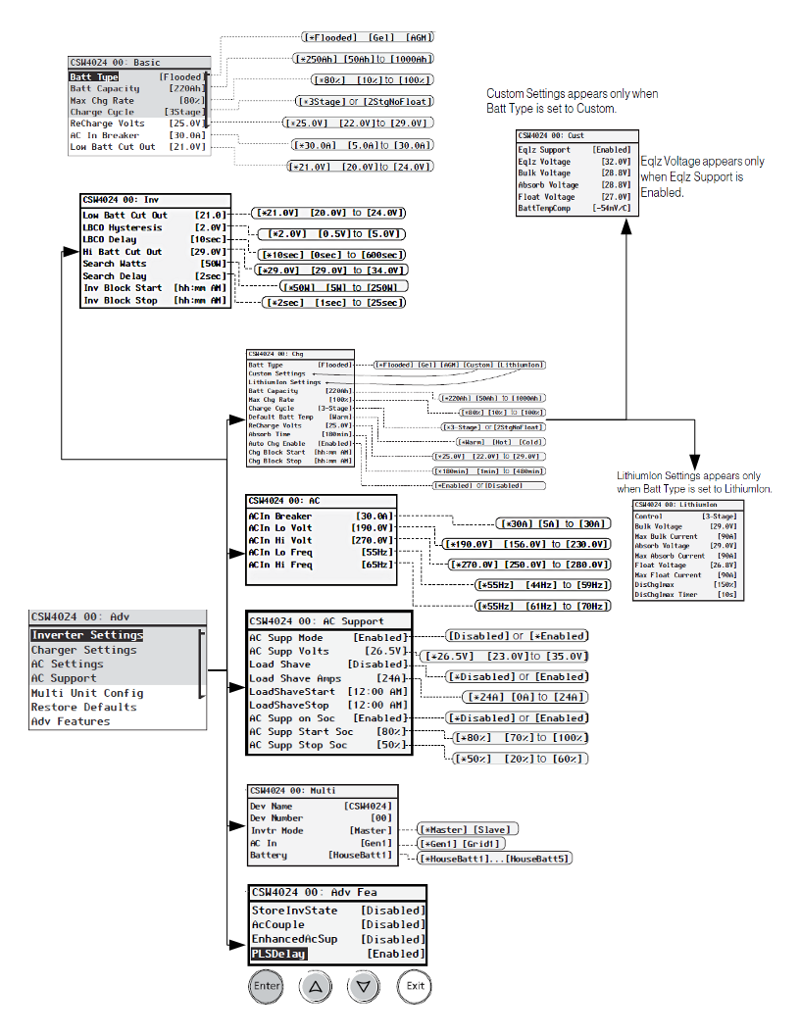

InsightCloud SW Menus
These screenshots are from demonstration sites using random data on InsightCloud - https://www.insightcloud.se.com

To see this data for yourself and to practice using InsightCloud, point your web browser to https://www.insightcloud.se.com, create an account, and create a new site using;

- URN: urn:dev:opm:000054-Combox-587AC6N1CSWCL1
- SERIAL NUMBER: SESA405035

This Schneider demo site simulates a SW installation with a Schneider Conext MPPT 60 charge controller, a Conext battery monitor and a Conext Automatic Generator Start.
Input any site name you wish, any date you want for the commissioning date and estimate the site, battery bank and inverter sizes using your preferred method. For this example, it was named Schneider Insight 2 Demo Site 1.

From the InsightCloud home page click the demo site you set up above.

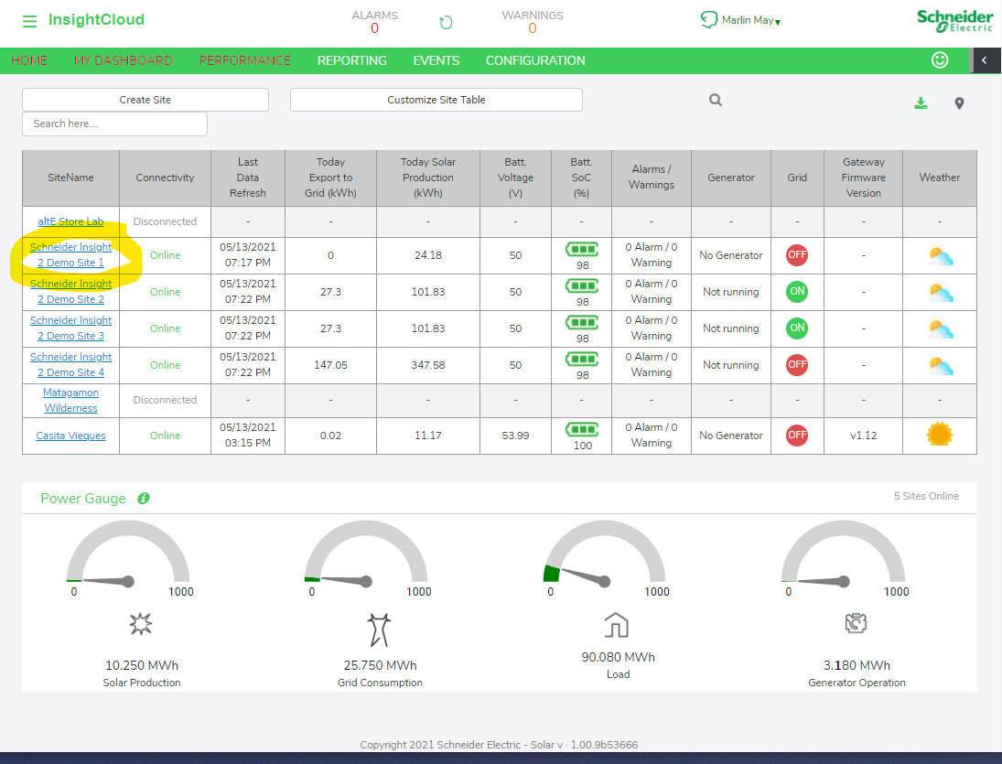

On the Site Overview page, click “Configuration” to select the demo site you set up earlier.

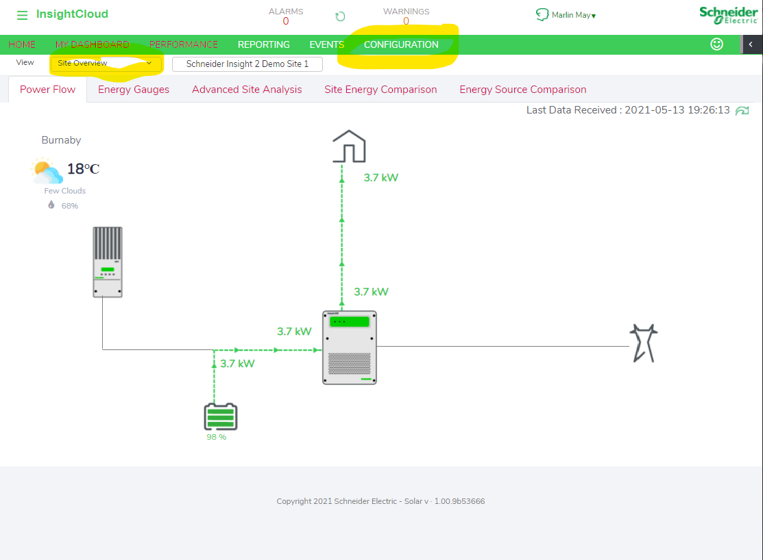

In the Device List, Click “Inverter Charger” to reveal the SW inverter. Click on one of them to load the settings control panel. To see all of the settings categories, click the “Collapse all” button. The settings mentioned above are all available here.

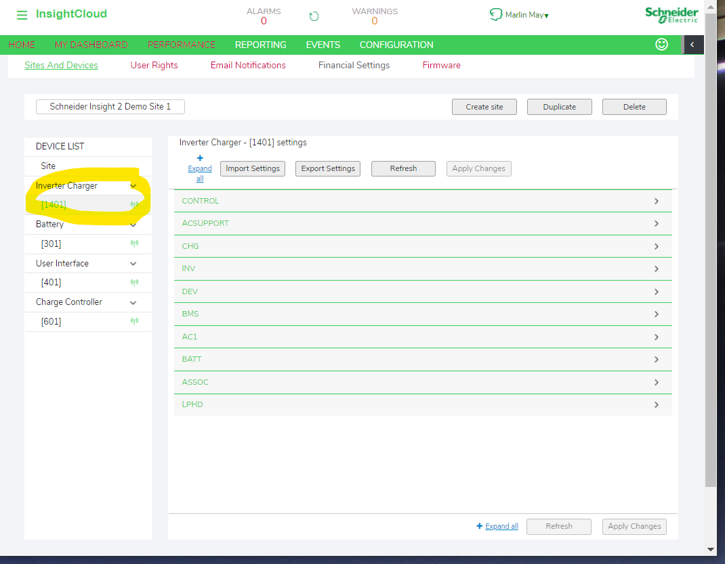

Links
SW Installation Guide:
- https://tinyurl.com/SwInstallationGuide
SW Owner’s Guide:
- https://tinyurl.com/SwOwnersGuide
KiloVault HLX/CHLX Manual:
- https://www.altestore.com/static/datafiles/Others/KiloVault_HLX_Series_Manual_V2.1.2_April022021.pdf
KiloVault HAB Manual:
- https://www.altestore.com/static/datafiles/Others/KLV%20HAB%20Installation%20and%20User%20Manual%20Rev%202.06.pdf
KiloVault PLC Manual:
- https://www.altestore.com/static/datafiles/Others/KiloVault%202100%20PLC%20Installation%20and%20User%20Manual%20Rev%201.04.pdf

